**How to Annotate and Sign Documents**

**On making annotations:**

1. Annotation can be done only during routing of documents and using privilege accounts for “MANAGER”, “GM”, or “EAGM”.
2. Login to e-Dokyumento as “manager-finance” or any of the privileged accounts and then select ‘Routing’ or ‘Incoming’ from the side menu.

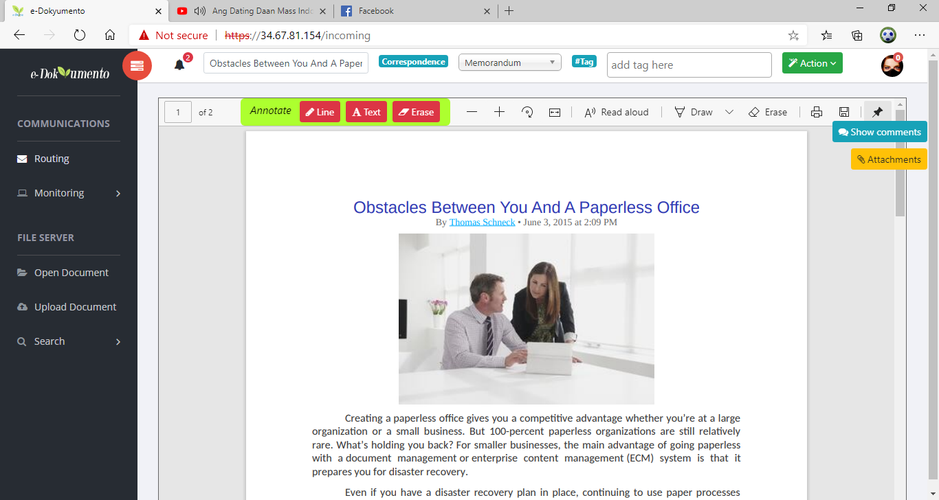

1. Click any of the three annotate buttons available and wait until the “Loading” status disappears.

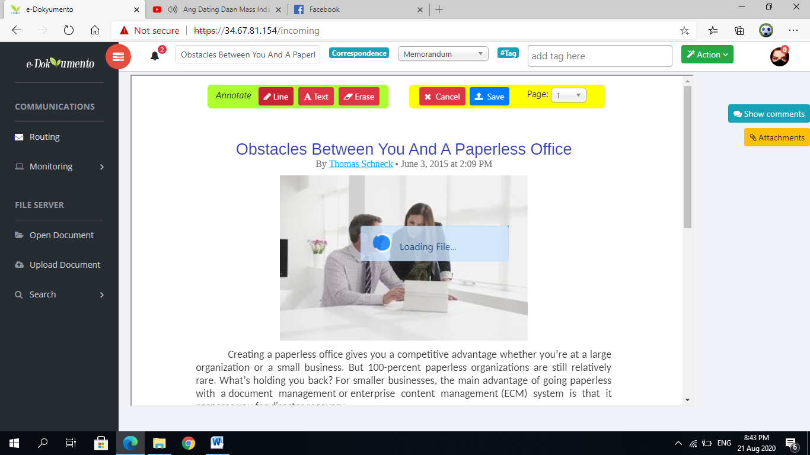

1. Click or draw inside the PDF Canvas and click “save” when done.

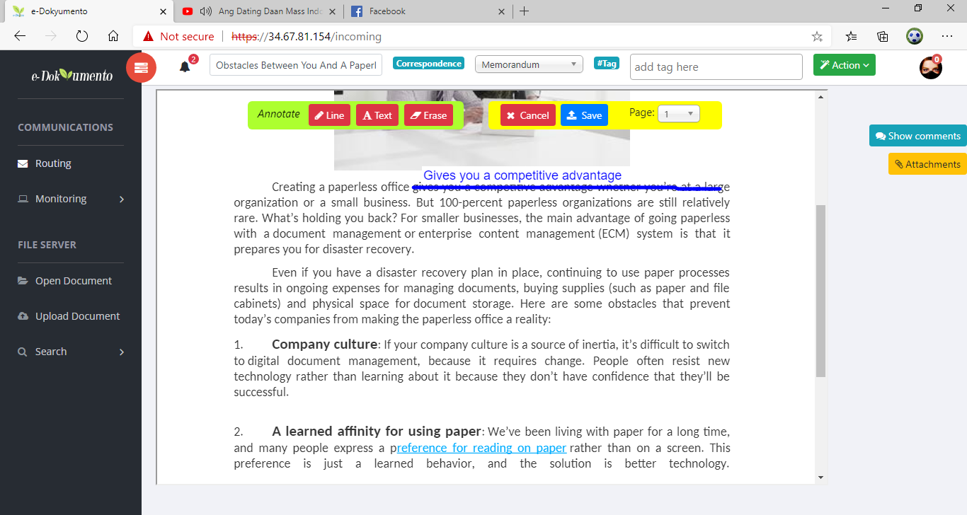

1. When annotating on different page click to select the page number from dropdown button. You can only annotate a single page. When annotating multiple pages, save the page every time you make annotation and repeat step 4.



1. You can now route the document to other department or back to the originator for correction.

**On signing the document:**

1. Signing of document can be done during opening of the document and using privilege accounts for “MANAGER”, “GM”, or “EAGM”.
2. To do this, click ‘Open Document’ from the side menu. Browse the folder and select the file. After the file is loaded, click ‘Action’ then ‘Sign Document’.

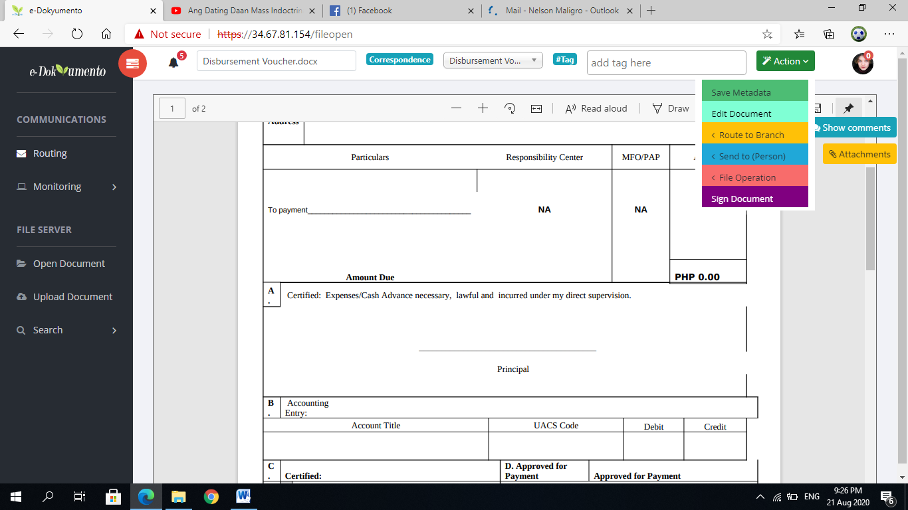

1. Signing of document can also be done when opening document from the mail. To do this, click your avatar icon, then ‘Mail’, then select the file to open.

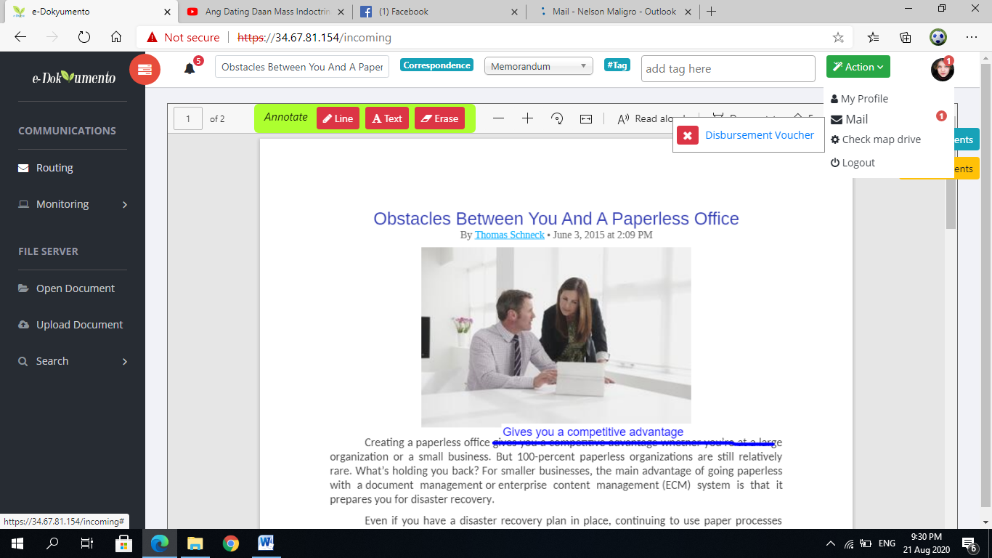

1. After the file is loaded, click ‘Action’ then ‘Sign Document’.
2. Using your mouse scroll bar, move into the page of the document and click on any of the location to attach the signature.

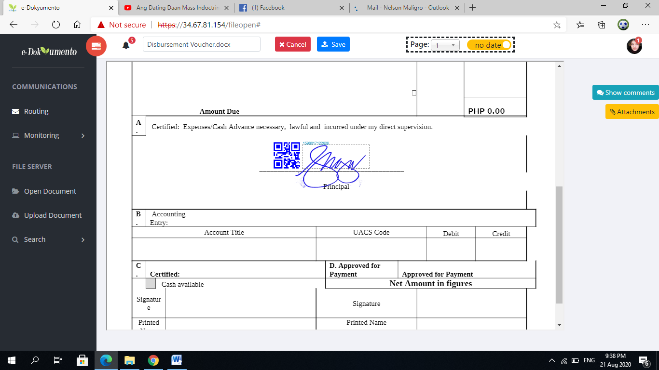

1. You can adjust the location of the signature by dragging the image. You can also sign on different page by selecting the page number on the top.
2. Click ‘save’ button when done. Type-in your password to confirm the signature and click ‘Validate’ button.

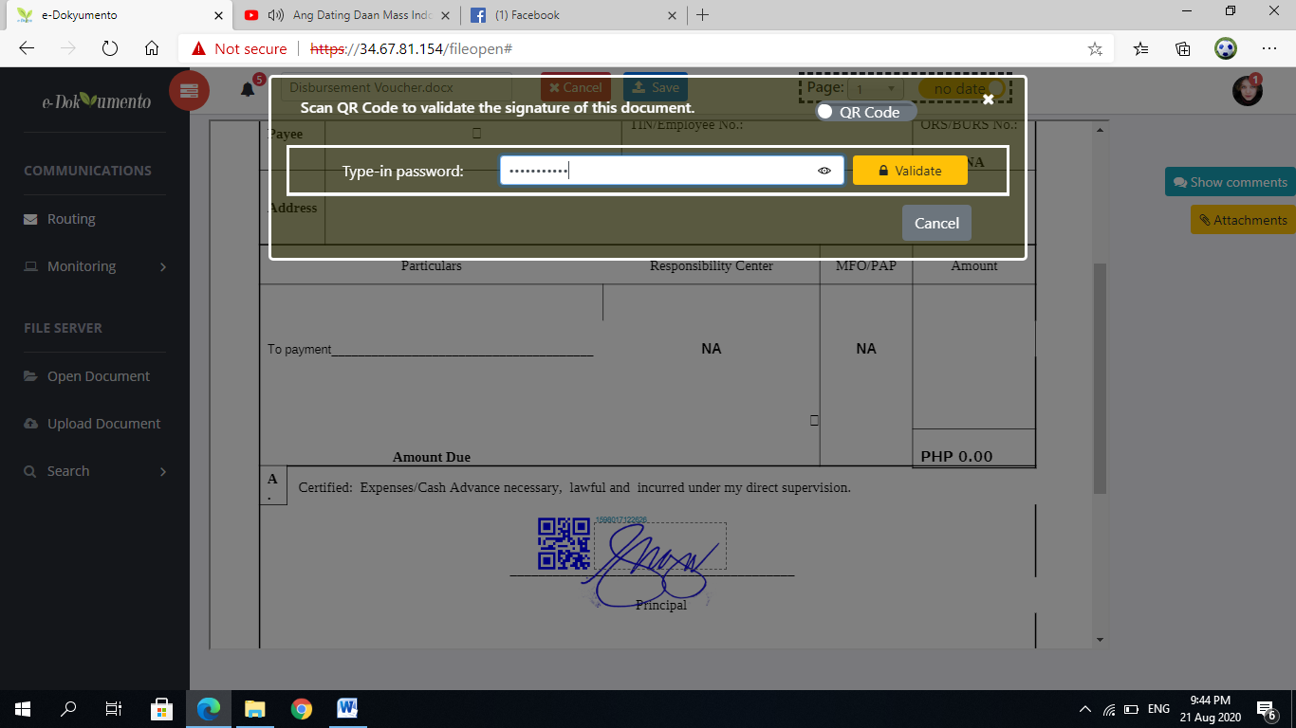

1. You can now route the document or send it to other users.

**On signing the document using GM and EAGM accounts:**

1. The boss and the assistant boss can easily sign the document through their friendly interface.
2. Login to e-Dokyumento as “boss” or ‘’boss.wannabe” and then select ‘Routing’ or ‘Incoming’ from the side menu.
3. Click on the “Sign this document” button. If sign button is not displayed, click to toggle “Sign” and “Release” switch button.

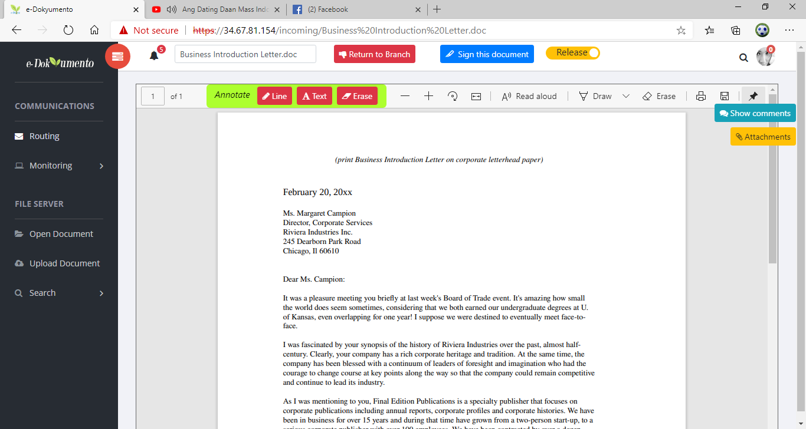

1. Using your mouse scroll bar, move into the page of the document and click on any of the location to attach the signature.
2. Click either from “Release” or “Return to Branch” button to effect the signature and route the document.

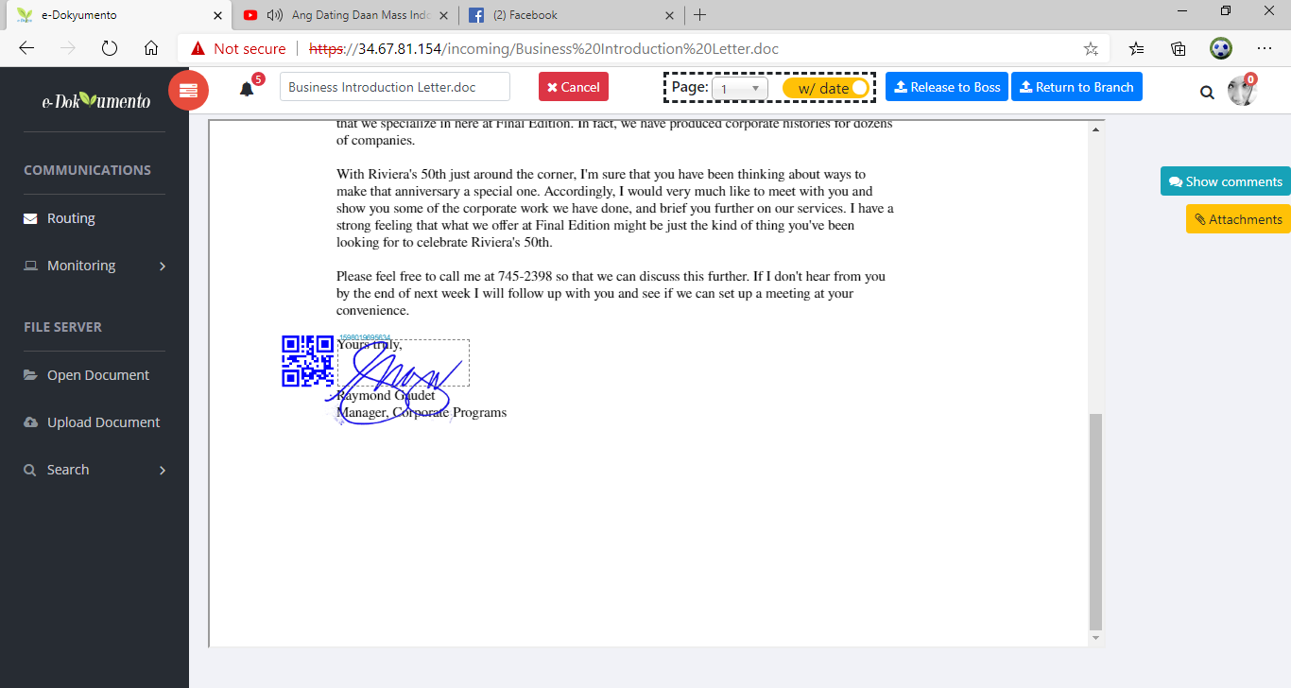

1. When prompted to validate the signature, type-in your password and click ‘Validate’ button.



1. The document is now endorsed to the upper management (boss) or released to the secretary for appropriate action.

